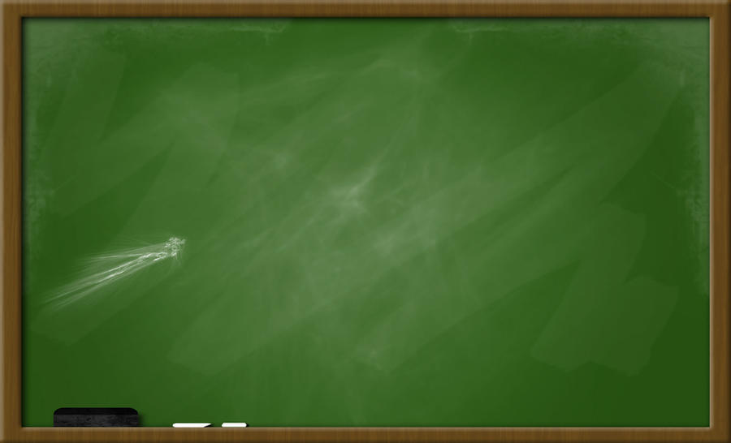

**8:20-8:45**  **Announcements/Morning Meeting**

**8:45-9:30 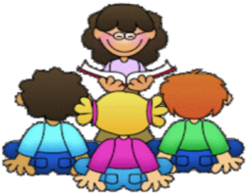 Reading Workshop**

**9:30-9:40 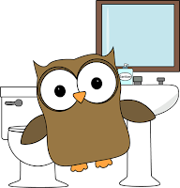 Restroom Break**

**9:40-10:30 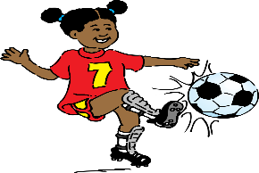 Related Arts: P.E. (M/T), MUSIC (W), ART (Th/F)**

**10:30-11:30**  **Reading/Writing Workshop**

**11:30-12:00 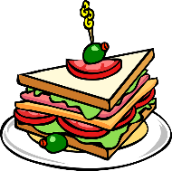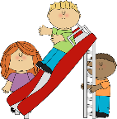 Lunch/Recess**

Restroom Break**



**12:10-12:25 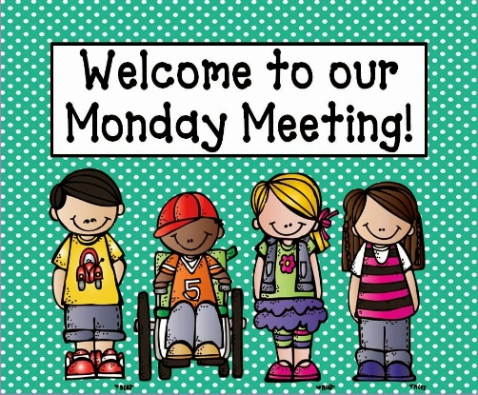 Class Meeting**

**12:25-1:00 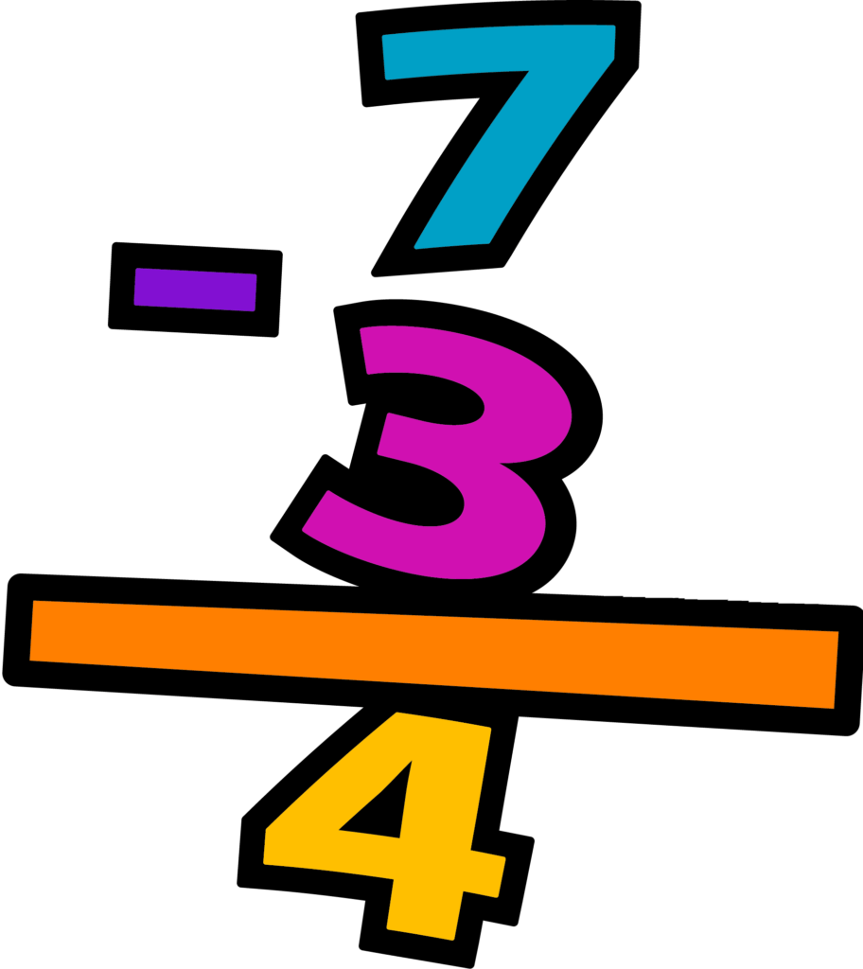 Math**

D. E. A. R.**

Math**

**2:10-2:40 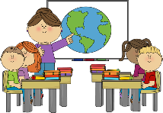 Science/Social Studies**

Character Counts/Intervention**

Prepare for Dismissal/P.M. Announcements**